Medical Store System



Name:

Muhammad Usman 037

Submitted to.

Muhammad Kamran

Table of Content

1. Introduction to medical shop......................................................1  
  
1.1.scope &objectives....................................................................2  
  
1.2 background..............................................................................3

2. Requirements............................................................................4  
  
2.1 functional Requirements.........................................................5  
  
2.2 nonfunctional Requirements...................................................6

3. Design………………………………………………………………7

3.1 Class diagram.........................................................................8  
  
3.2 activity diagarm.......................................................................9  
  
3.3 use case diagram...................................................................10  
  
3.4 sequence diagram..................................................................11  
  
4. Implementation.........................................................................12

4.1 Login……………………………………………………………….13

4.2 Signup…………………………………………………………….14

4.3 Profile……………………………………………………………...15

4.3.1 Add Stock…………………………………………………….…16

4.3.2 Update Stock……………………………………………………17

4.3.3 Remove Stock………………………………………….……….18

4.3.4 View Stock………………………………………...…………….19

4.3.5 Sell item……………………………………….…………………20

4.3.6 View Sell Item List…………………….……………………….21

4.3.7 Add Client…………………………....………………………….22

4.3.8 Remove Client…………………...……………………………...23

4.3.9 View Client………………….………………………………..….24

4.3.10 Add Company…………...…………………………………….25

4.3.11 Remove Company…………………………………………….26

4.3.12 View Company…………………………………………………27

LIST OF TABLES  
Table 1. ………………..................................................................28  
 3.1.2 Login………………………………………………………....29

3.1.3 Add company……………………………………………….30

3.1.4 Add stock…………………………………………………...31

3.1.5 Add clients………………………………………………….32

3.1.6 Sell item…………………………………………………….33

3.1.7 Search stock……………………………………………….34

3.1.8 Add login User………………………………………………35

3.1.9 Generate Manager Report…………………………………36

3.1.10 Generate stock in and Sell report………………..………37

3.1.11 Change password…………………………..……………..38

.

Table 2. ………………………………………………………..…….39

2.1 Aggregation vs. Decomposition……………….. ……..40   
  
  
 LIST OF FIGURES  
  
Figure 1. Use Case Diagram of Medical store…………………………41  
  
Figure 2. Activity Diagram……………………………………… ……..42

2.1 login Interface……………………………………………...….43

2.2 Add Login User………………………………………………..44

2.3 Add Company…………………………………………………45

2.4 Add Stock………………………………………………..…….46

2.5 Add client. …………………………………………………….47

Figure 3. Class Diagram of Medical store………………………………….48

Figure 4. Sequence Diagram of Medical store……………………………..49

Chapter 1

Introduction to medical shop.

1.1 Introduction  
 This project is used mainly for medical shop to maintain the detail of medical shop such as stock and account.  
this medical shop management software is so designed as to ease the work load of medical shop professional. The main feature includes inventory and stock control, accounting, client management.

1.2 Scope and Objectives.  
 As this generic software it can be used by a wide variety of outlets to automate the process of manually maintaining the records related to the subject of maintaining the stock and cash flows.  
 This project is basically update the manual chemist inventory system to automated inventory system, so that organization can manage their record in efficient and organized form.  
this software helps you to track all the products of medical shop moreover it’s medical shop accounting software. Flexible and adaptive software suited to medical shops or stores or pharmacies of any size.

project characteristics :  
customer management   
sales management  
reporting

1.3 Background  
 A medical store needs to maintain the medicines and other products using a computerized system. It is planning to create a network of computer which should be placed at various sales and cash counters. It also proposes to have a centralized workstation for the database and system administrators. Customer orders are accepted at the sales counter which is turn produces a medicine collection challan. The challan includes the order number, name of medicine, batch number, date of expiry, shelf number where it is kept and quantity ordered. One order may contain more than one medicine. As per challan, medicines are put in a basket by a person, who passes it to billing assistant. Billing assistant checks the medicine is as per the challan, any shortcoming is either corrected or reported to customer. On receiving conformation from the customer the bill is generated. The cash collects the money as per the bill and dispenses the medicine to the customer.

chapter 2  
 Requirements

2.1 Functional Requirements.

* The project must request username and password for access to data, only after authentication will allow to access to the system.
* The project must require high level of error correction and input validation.
* The project must allow update information of product, Customer, Stock and Company.
* The project must identify the product, Customer, Stock and Company by a unique numeric identifier derived from a function performed on the customer’s birth date or product id.
* The software to be developed must operate without interruption 24hrs a day.
* The software to be developed shall display the correct time of day in compliance with standard (ISO etc.).
* The software must retrieve, update and store data from multiple input.
* The software must allow full and complete record search queries by users.
* The product must allow customer to view their own concern record allowing changes only to address, phone number after initial input.

2.2 Non-Functional Requirements.

* The software interface must follow design conventions which allow for familiar location of menus, etc.
* Input errors will be returned in red with appropriate message box.
* More than three attempts at login and failure will produce a red flag to system administrator.
* Response time should be minimum,
* System should automatically update after every transaction.

Chapter 3

Design

3.1 Use case.

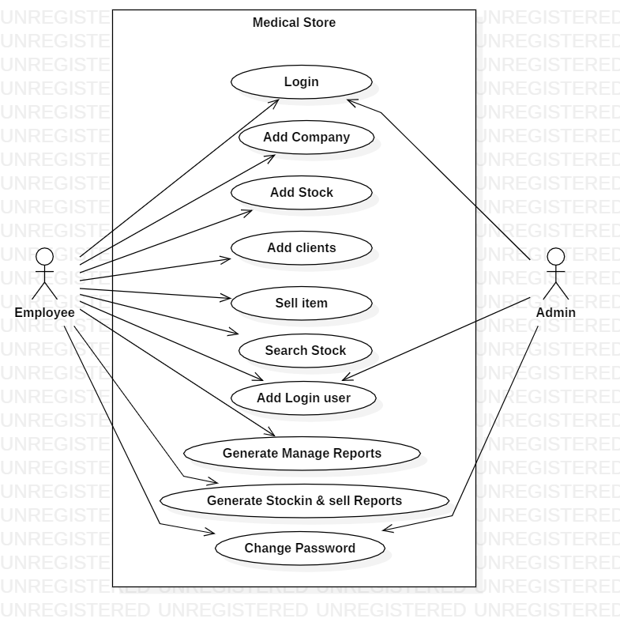

Figure 3.1.1

**USE CASE DESCRIPTION**

Table 3.1.2

|  |
| --- |
| **Use case** : Login |
| **Actor** : Employee , admin |
| **Goal :** to allow user to login and prevents other to access system |
| **Pre-condition**: You must be registered |
| **Post- condition**: login successfully |
| **Summary**: all the use case dependent on login use case |
| **Step**:   |  |  | | --- | --- | | **Actor action**   1. Enter the personal information about himself. | **System response**   1. Verify the user info and allow to access the system | |

Table 3.1.3

|  |
| --- |
| **Use case**: Add company |
| **Actor** : employee |
| **Goal**: this use case allow the employee to add the new medicine company in the medical store |
| **Pre-condition**: first of all you must be registered or login then access this use case |
| **Post-condition**: add company, delete company, company list, company reports etc.   |  | | --- | | **Summary** : company info | |
| **Steps:**   |  |  | | --- | --- | | **Actor action**   1. Employee enter the details of adding / removing company. | **System response**   1. The system database store the detail of company and show the store records to the user. | |

Table 3.1.4

|  |
| --- |
| **Use case**: Add stock |
| **Actor**: employee |
| **Goal** : this use case allow the employee add new stock when old stock will be insufficient. |
| **Pre-condition**: must be login then access this use case |
| **Post-condition**: update stock, new stock ,remove stock ,view stock |
| **Summary**: stock info   |  |  |  | | --- | --- | --- | | **Steps:**   |  |  | | --- | --- | | **Actor action**   1. Enter the detail of stock. | **System response**   1. The system database stores the detail of stock and show the store records to the user. | | |

Table 3.1.5

|  |
| --- |
| **Use case**: add clients |
| **Actor** : employee |
| **Goal**: this use case allow the employee to add the new clients data and remove the data of clients. |
| **Pre-condition**: must be login with the system. |
| **Post-condition**: add client, remove clients ,view client list |
| **Summary**: update clients detail   |  |  |  | | --- | --- | --- | | **Steps:**   |  |  | | --- | --- | | **Actor action**   1. Employee enter details of client. | **System response**   1. The system database stores the data of clients and show the stores data to the user. | | |

Table 3.1.6

|  |
| --- |
| **Use case**: sell item |
| **Actor:** employee |
| **Goal** : this use case allow the employee to sell item and show the records about sell item |
| **Pre-condition** : must be login with the system and perform this operation |
| **Post-condition**: sell item name , item quantity, item price, customer name and expiry date. |
| **Summary** : show detail about the sell item |
| **Steps:**   |  |  | | --- | --- | | **Actor action**   1. Employee enter the detail of sell item for selling. | **System response**   1. The system database updates the record about the sell item. | |

Table 3.1.7

|  |
| --- |
| **Use case**: Search stock |
| **Actor**: employee |
| **Goal**: this use case allow the employee to search the stock in the medical store |
| **Pre-condition**: must be login with the system and perform this function |
| **Post-condition**: search stock , add stock , remove stock, view stock |
| **Summary**: update the records of stocks |
| **Steps:**   |  |  | | --- | --- | | **Actor action**   1. Employee search the stock when stock is insufficient otherwise not | **System response**   1. The system database notify the user when stock in not available. | |

Table 3.1.8

|  |
| --- |
| **Use case**: add login user |
| **Actor** : employee, admin |
| **Goal** : this use case allows admin when new employee login with the system and the admin add the employee into system database |
| **Pre-condition** : must be registered |
| **Post-condition**: successfully login |
| **Summary** : updates the records of new employee |
| **Steps:**   |  |  | | --- | --- | | **Actor action**   1. Admin enter the data of new employee in the system. | **System response**   1. The system database update the records of new employee and store into system database. | |

Table 3.1.9

|  |
| --- |
| **Use case** : generate manage reports |
| **Actor** : employee |
| **Goal** : to review or generates reports of all medicine after week or month or year |
| **Pre-condition**: employee must have full details about the medicine |
| **Post-condition**: fetch the data from database and print the report |
| **Summary**: login, Manage medicine details ,database update |
| **Steps:**   |  |  | | --- | --- | | **Actor action**   1. Employee collect all the detail from the system database and generate report. | **System response**   1. The system database allow the user to fetch the data. | |

Table 3.1.10

|  |
| --- |
| **Use case** : generate stock in and sell reports |
| **Actor** : employee |
| **Goal:** to generate the reports of medicine which are in stock and which has been sold after week ,months or year |
| **Pre-condition**: employee must have full detail about the medicine |
| **Post-condition**: fetch the data from database and print the report |
| **Summary**: login, Manage medicine details ,database update |
| **Steps:**   |  |  | | --- | --- | | **Actor action**   1. Employee collect all the detail from the system database and generate report. | **System response**   1. The system database allow the user to fetch the data. | |

Table 3.1.11

|  |  |  |  |  |  |  |  |  |  |
| --- | --- | --- | --- | --- | --- | --- | --- | --- | --- |
| |  | | --- | | **Use case**: change password | | **Actor** : employee, admin | | **Goal**: this use case allow the employee and admin to change password easily if employee and admin wants | | **Pre-condition:** must be login with the system | | **Post-condition**: change password , update database | | **Summary**: login with the system and change password | | **Steps**:   |  |  | | --- | --- | | Actors action   1. User wants to update the password | **System response**   1. System database update the password of user and show the pop message successfully change the password. | | |

3.2 Activity Diagram.

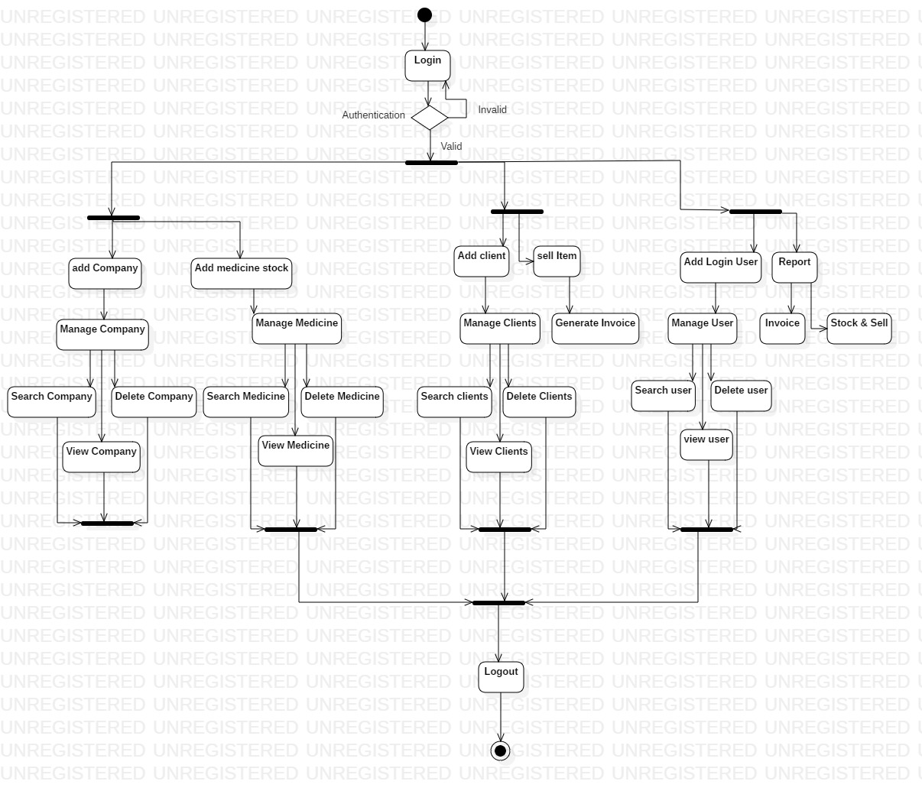

Figure 3.2.1

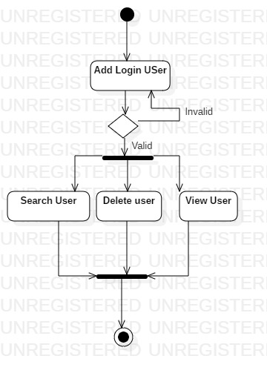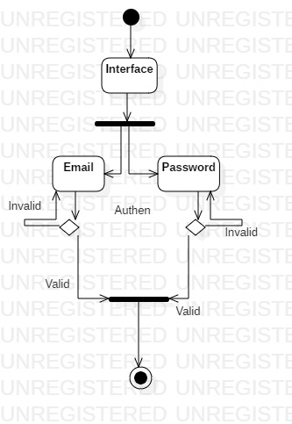

Figure 3.2.2 Figure 3.2.3

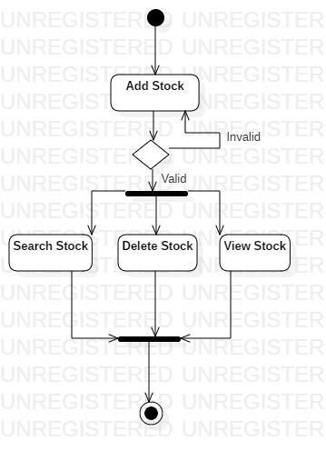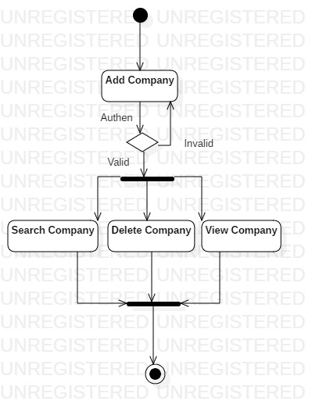

Figure 3.3.4

Figure 3.3.3

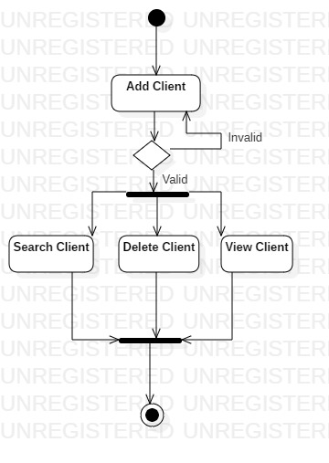

Figure 3.3.5

##### 3.2.1 Initial State or Start Point

A small filled circle followed by an arrow represents the initial action state or the start point for any activity diagram. For activity diagram using swim lanes, make sure the start point is placed in the top left corner of the first column.



##### 3.2.2 Activity or Action State

An action state represents the non-interruptible action of objects. You can draw an action state in Smart Draw using a rectangle with rounded corners.

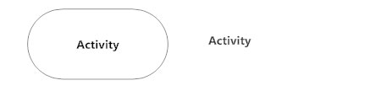

##### 3.2.3 Action Flow

Action flows, also called edges and paths, illustrate the transitions from one action state to another. They are usually drawn with an arrowed line.

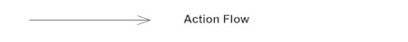

##### 3.2.4 Object Flow

Object flow refers to the creation and modification of objects by activities. An object flow arrow from an action to an object means that the action creates or influences the object. An object flow arrow from an object to an action indicates that the action state uses the object.

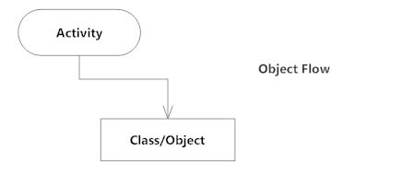

##### 3.2.5 Decisions and Branching

A diamond represents a decision with alternate paths. When an activity requires a decision prior to moving on to the next activity, add a diamond between the two activities. The outgoing alternates should be labeled with a condition or guard expression. You can also label one of the paths "else."

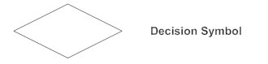

##### 3.2.6 Guards

In UML, guards are a statement written next to a decision diamond that must be true before moving next to the next activity. These are not essential, but are useful when a specific answer, such as "Yes, three labels are printed," is needed before moving forward.

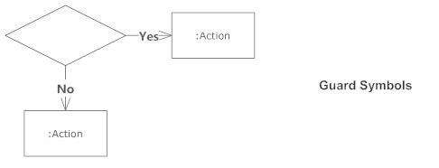

##### 3.2.7 Synchronization

A fork node is used to split a single incoming flow into multiple concurrent flows. It is represented as a straight, slightly thicker line in an activity diagram.

A join node joins multiple concurrent flows back into a single outgoing flow.

A fork and join mode used together are often referred to as synchronization.

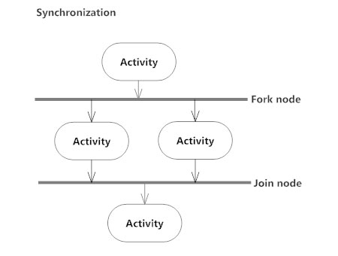

##### 3.2.8 Time Event

This refers to an event that stops the flow for a time; an hourglass depicts it.

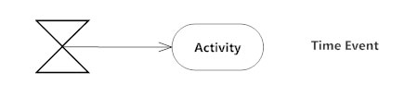

##### 3.2.9 Merge Event

A merge event brings together multiple flows that are not concurrent.

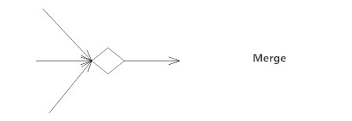

##### 3.2.10 Sent and Received Signals

Signals represent how activities can be modified from outside the system. They usually appear in pairs of sent and received signals, because the state can't change until a response is received, much like synchronous messages in a [sequence diagram](https://www.smartdraw.com/sequence-diagram/). For example, an authorization of payment is needed before an order can be completed.

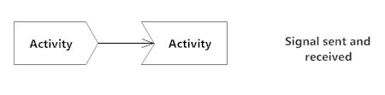

3.3 Class Diagram.

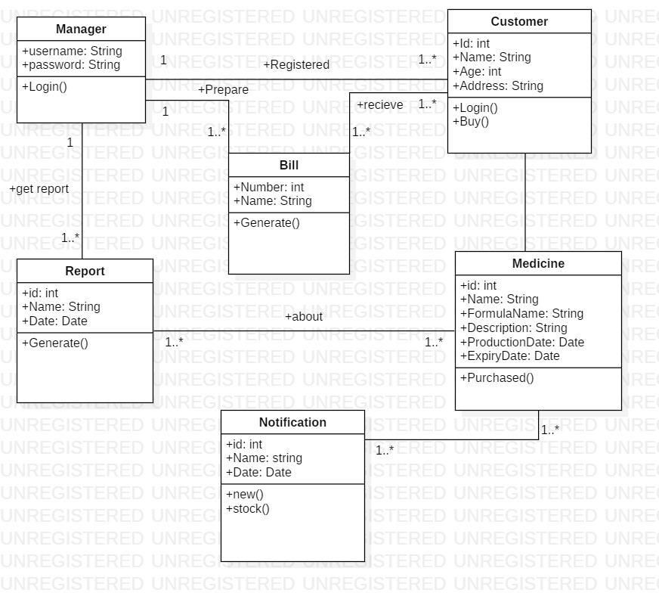

3.3.1 Class Name

[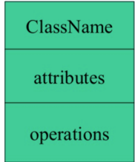](https://www.guru99.com/images/1/051818_1150_UMLClassDia1.png)

The name of the class is only needed in the graphical representation of the class. It appears in the topmost compartment. A class is the blueprint of an object which can share the same relationships, attributes, operations, & semantics. The class is rendered as a rectangle, including its name, attributes, and operations in sperate compartments.

Following rules must be taken care of while representing a class:

1. A class name should always start with a capital letter.
2. A class name should always be in the center of the first compartment.
3. A class name should always be written in **bold**format.
4. An abstract class name should be written in italics format.

3.3.2 Attributes.

An attribute is named property of a class which describes the object being modeled. In the class diagram, this component is placed just below the name-compartment.

[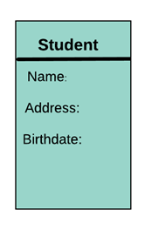](https://www.guru99.com/images/1/051818_1150_UMLClassDia2.png)

A derived attribute is computed from other attributes. For example, an age of the student can be easily computed from his/her birth date.

[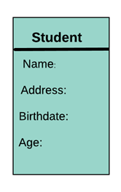](https://www.guru99.com/images/1/051818_1150_UMLClassDia3.png)

Attributes characteristics

* The attributes are generally written along with the visibility factor.
* Public, private, protected and package are the four visibilities which are denoted by +, -, #, or ~ signs respectively.
* Visibility describes the accessibility of an attribute of a class.
* Attributes must have a meaningful name that describes the use of it in a class.

3.3.3 Relationships

There are mainly three kinds of relationships in UML:

1. Dependencies
2. Generalizations
3. Associations

3.3.3.1 Dependency

A dependency means the relation between two or more classes in which a change in one may force changes in the other. However, it will always create a weaker relationship. Dependency indicates that one class depends on another.

In the following example, Student has a dependency on College

[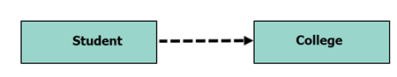](https://www.guru99.com/images/1/051818_1150_UMLClassDia4.png)

3.3.3.2 Generalization:

[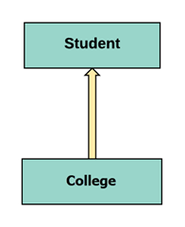](https://www.guru99.com/images/1/051818_1150_UMLClassDia5.png)

A generalization helps to connect a subclass to its superclass. A sub-class is inherited from its superclass. Generalization relationship can't be used to model interface implementation. Class diagram allows inheriting from multiple super classes.

In this example, the class Student is generalized from Person Class.

3.3.3.3 Association:

This kind of relationship represents static relationships between classes A and B. For example; an employee works for an organization.

Here are some rules for Association:

* Association is mostly verb or a verb phrase or noun or noun phrase.
* It should be named to indicate the role played by the class attached at the end of the association path.
* Mandatory for reflexive associations

In this example, the relationship between student and college is shown which is studies.

[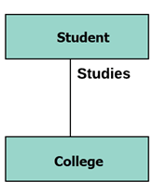](https://www.guru99.com/images/1/051818_1150_UMLClassDia6.png)

3.3.4 Multiplicity

[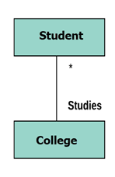](https://www.guru99.com/images/1/051818_1150_UMLClassDia7.png)

A multiplicity is a factor associated with an attribute. It specifies how many instances of attributes are created when a class is initialized. If a multiplicity is not specified, by default one is considered as a default multiplicity.

Let's say that that there are 100 students in one college. The college can have multiple students.

3.3.5 Aggregation.

Aggregation is a special type of association that models a whole- part relationship between aggregate and its parts.

[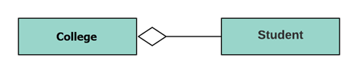](https://www.guru99.com/images/1/051818_1150_UMLClassDia8.png)

For example, the class college is made up of one or more student. In aggregation, the contained classes are never totally dependent on the lifecycle of the container. Here, the college class will remain even if the student is not available.

3.3.6 Composition.

[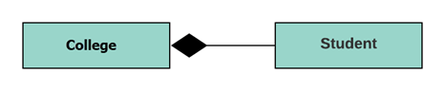](https://www.guru99.com/images/1/051818_1150_UMLClassDia9.png)

The composition is a special type of aggregation which denotes strong ownership between two classes when one class is a part of another class.

For example, if college is composed of classes student. The college could contain many students, while each student belongs to only one college. So, if college is not functioning all the students also removed.

3.3.7 Aggregation vs. Composition

|  |  |
| --- | --- |
| **Aggregation** | **Composition** |
| Aggregation indicates a relationship where the child can exist separately from their parent class. Example: Automobile (Parent) and Car (Child). So, If you delete the Automobile, the child Car still exist. | Composition display relationship where the child will never exist independent of the parent. Example: House (parent) and Room (child). Rooms will never separate into a House. |

3.3.8 Abstract Classes

It is a class with an operation prototype, but not the implementation. It is also possible to have an abstract class with no operations declared inside of it. An abstract is useful for identifying the functionalities across the classes. Let us consider an example of an abstract class. Suppose we have an abstract class called as a motion with a method or an operation declared inside of it. The method declared inside the abstract class is called a **move ()**.

This abstract class method can be used by any object such as a car, an animal, robot, etc. for changing the current position. It is efficient to use this abstract class method with an object because no implementation is provided for the given function. We can use it in any way for multiple objects.

In UML, the abstract class has the same notation as that of the class. The only difference between a class and an abstract class is that the class name is strictly written in an italic font.

An abstract class cannot be initialized or instantiated.

[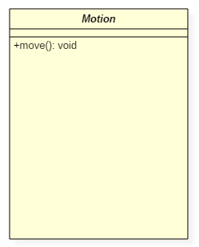](https://www.guru99.com/images/1/042319_0640_WhatisClass10.png)Abstract Class Notation

In the above abstract class notation, there is the only a single abstract method which can be used by multiple objects of classes.

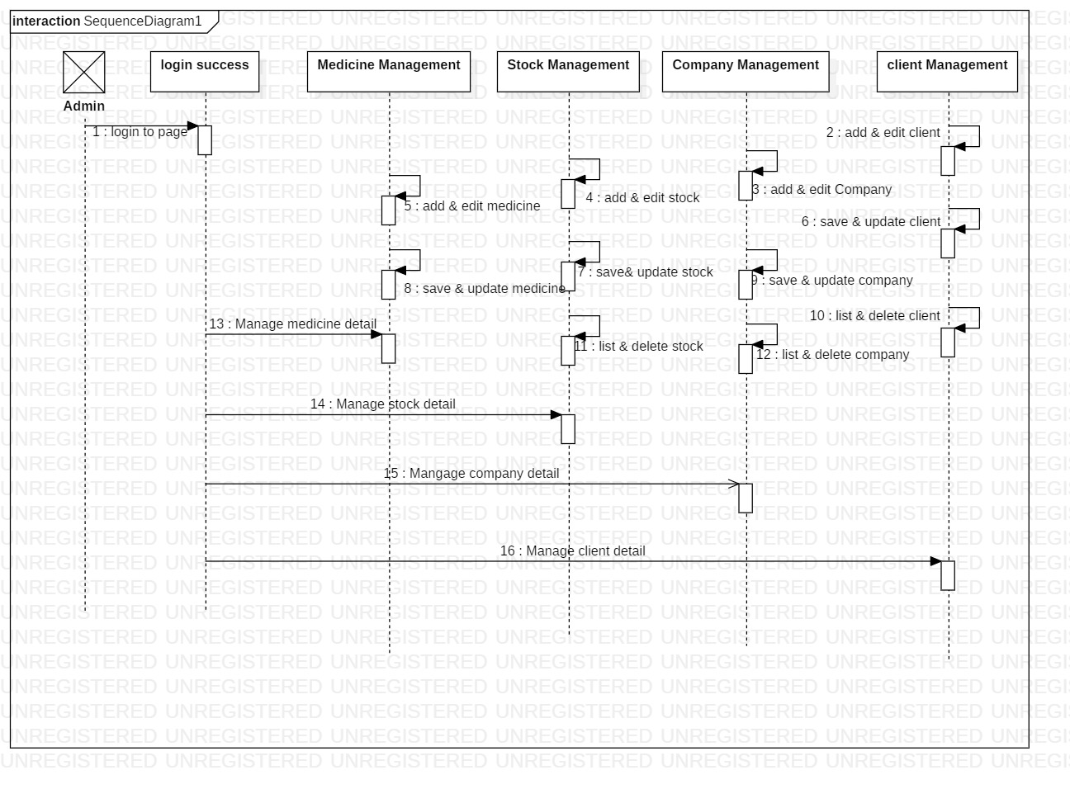3.4 Sequence Diagram

Figure 3.4.1

Chapter 4

Implementation

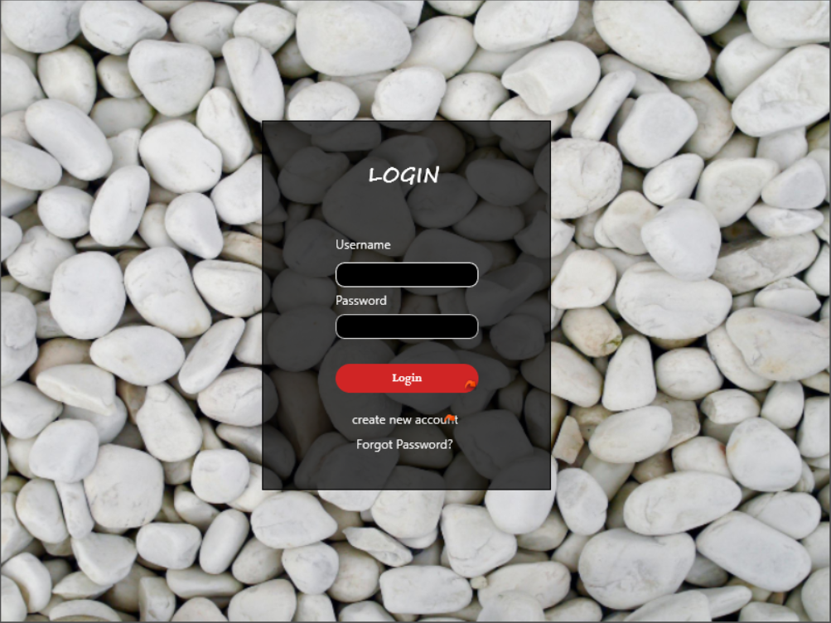4.1 Login.

4.2 Signup. 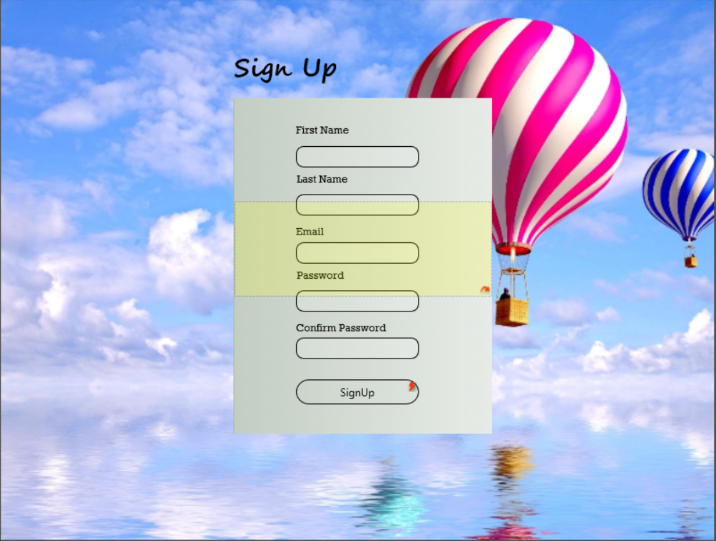

4.3 Profile.

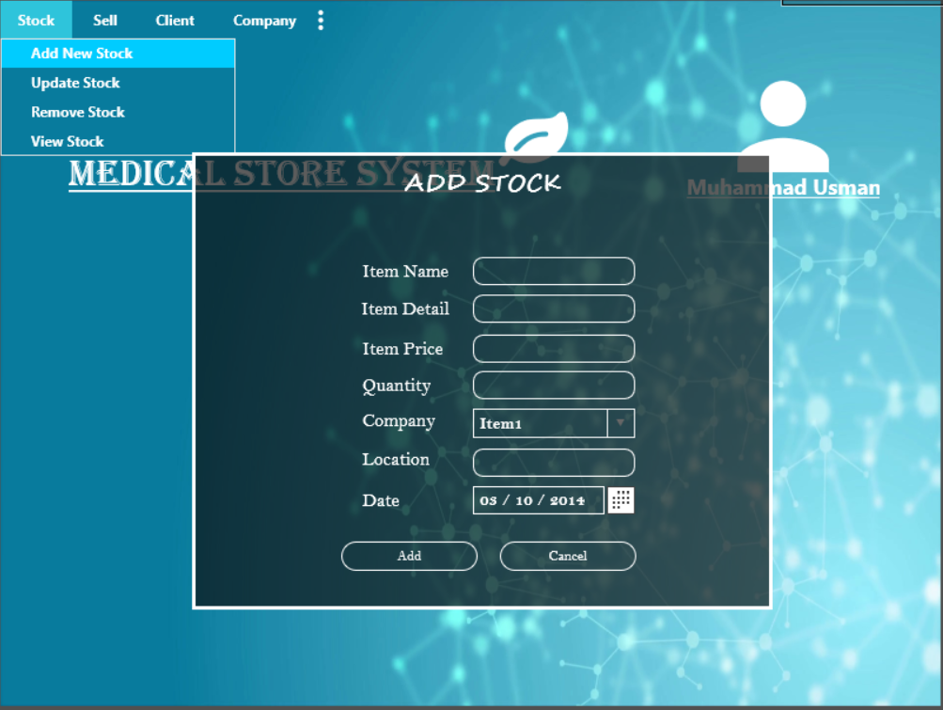

4.3.1 Add stock.

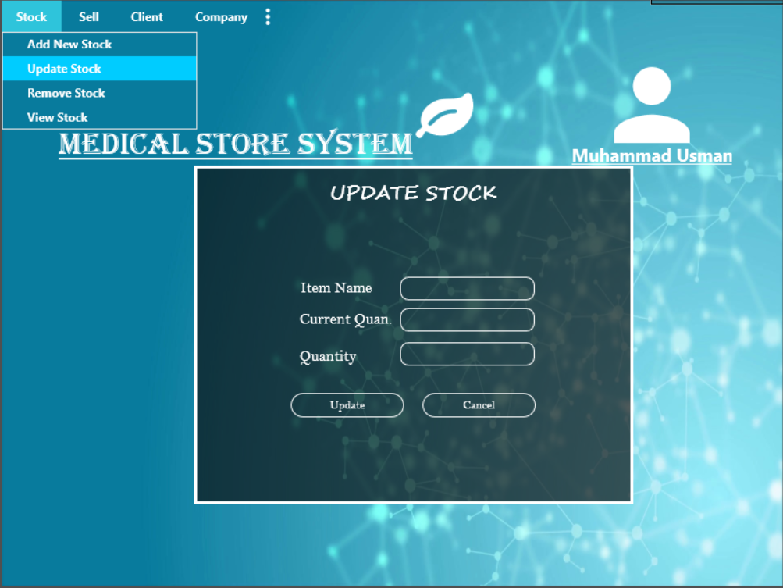

4.3.2 update stock.

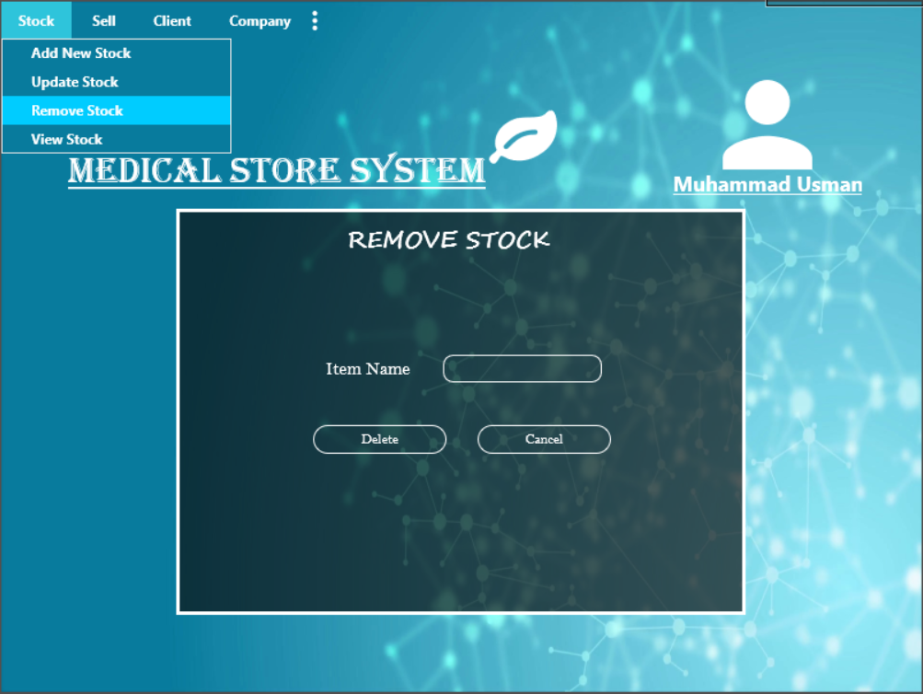

4.3.3

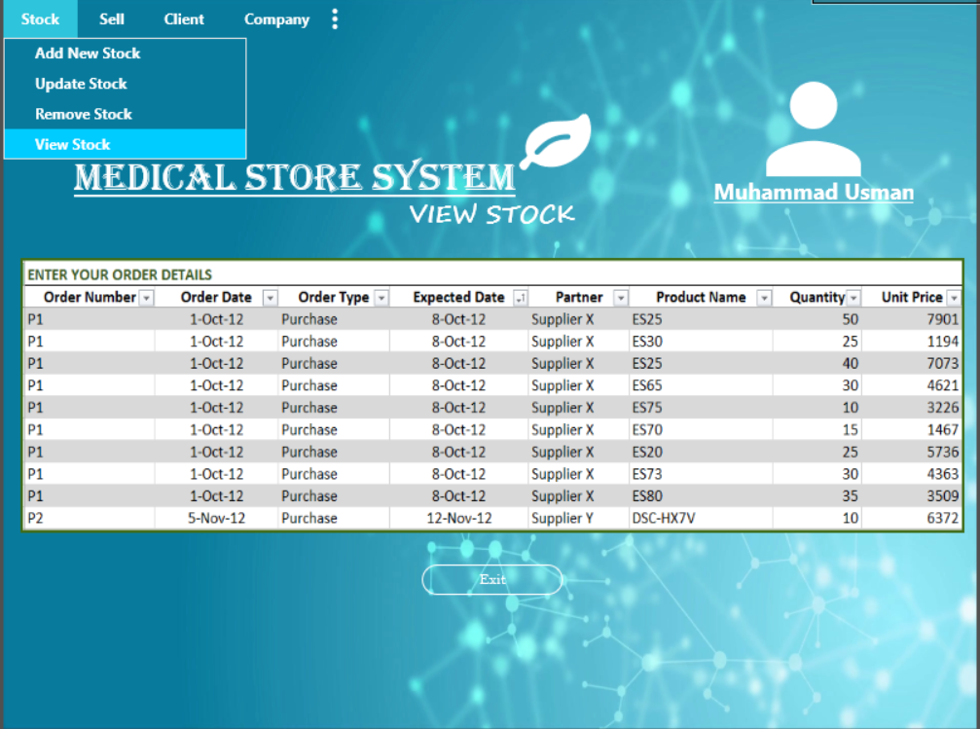

4.3.4 View Stock.

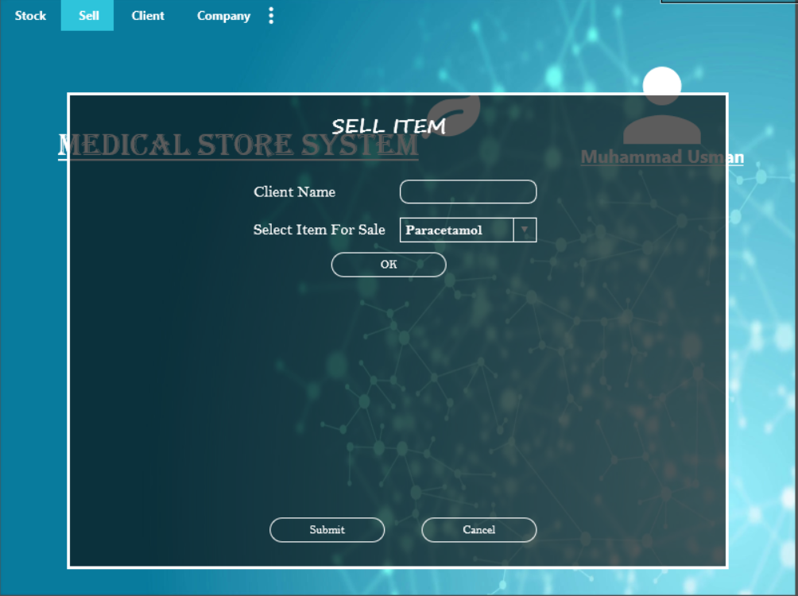

4.3.5 Sell Item.

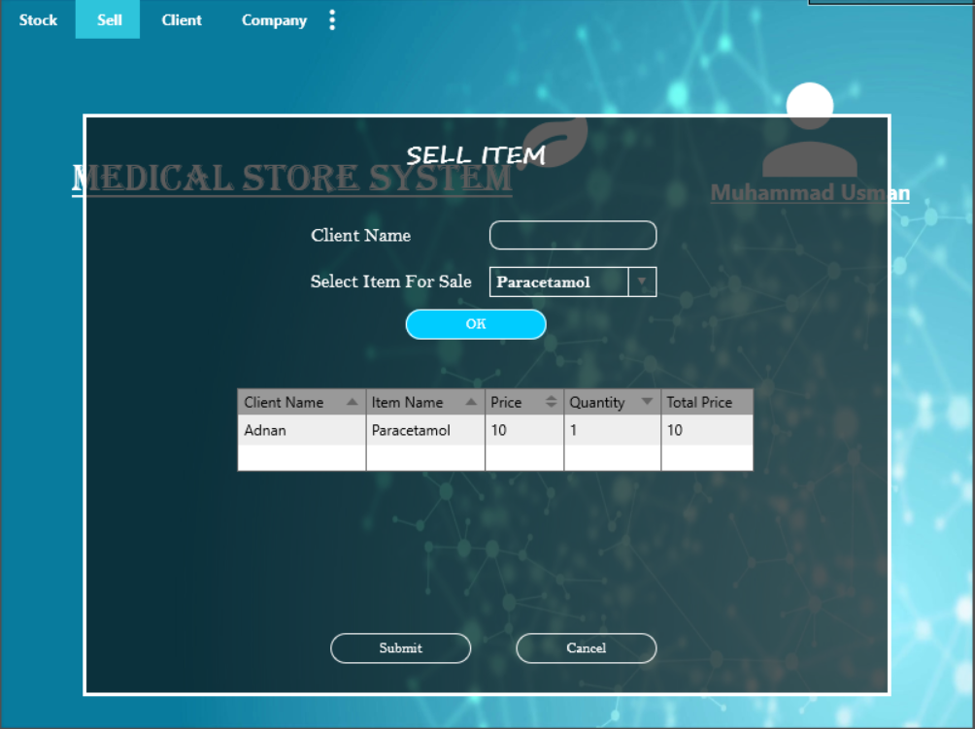

4.3.6 List of Sell item.

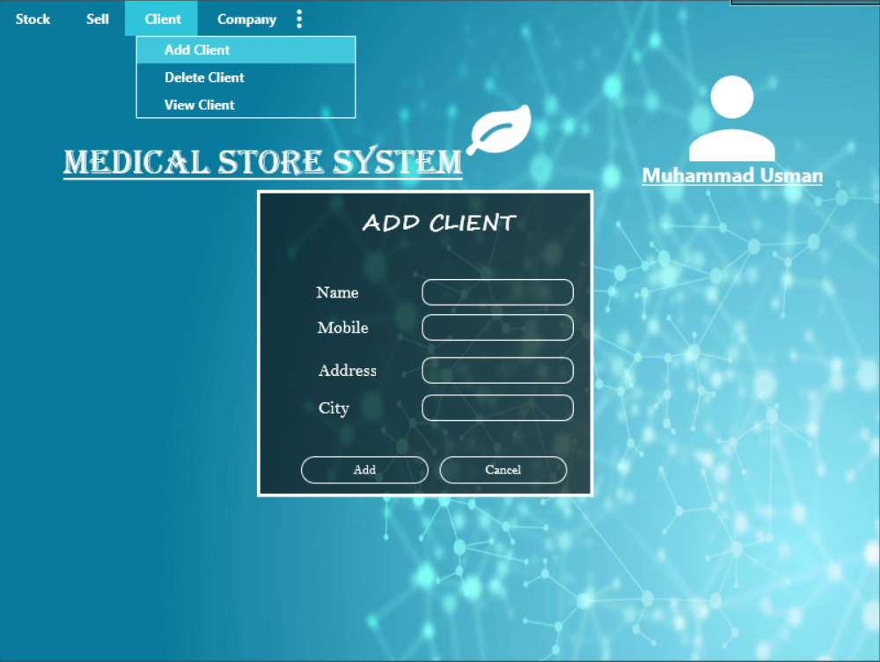

4.3.7 Add client.

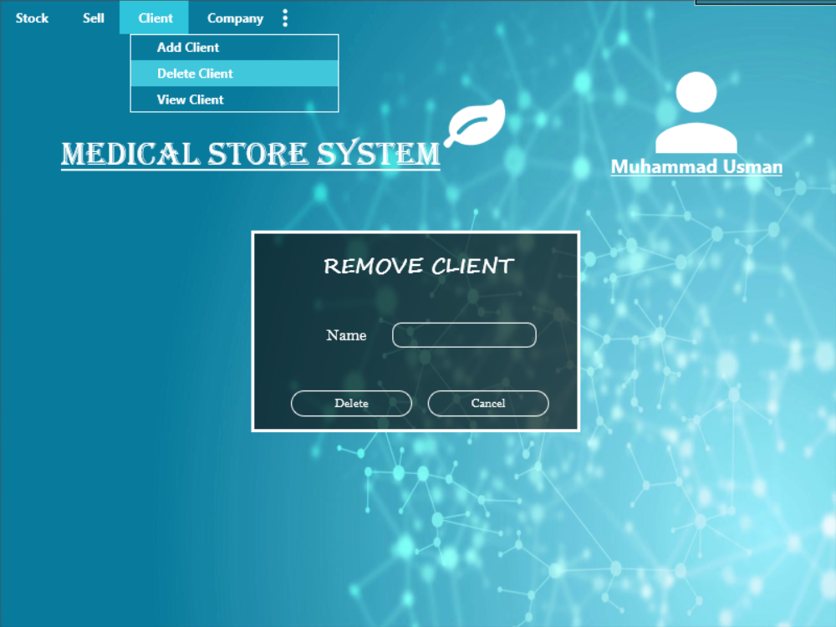

4.3.8 Remove client.

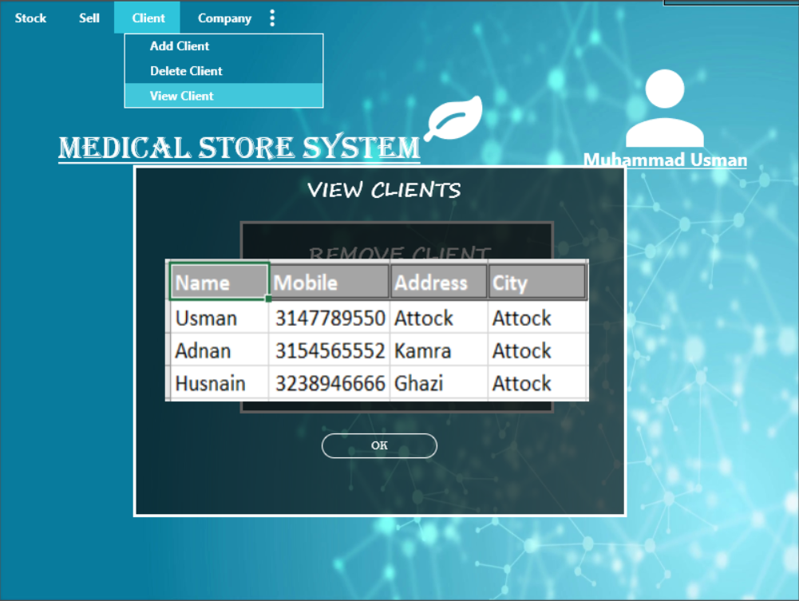

4.3.9 View client.

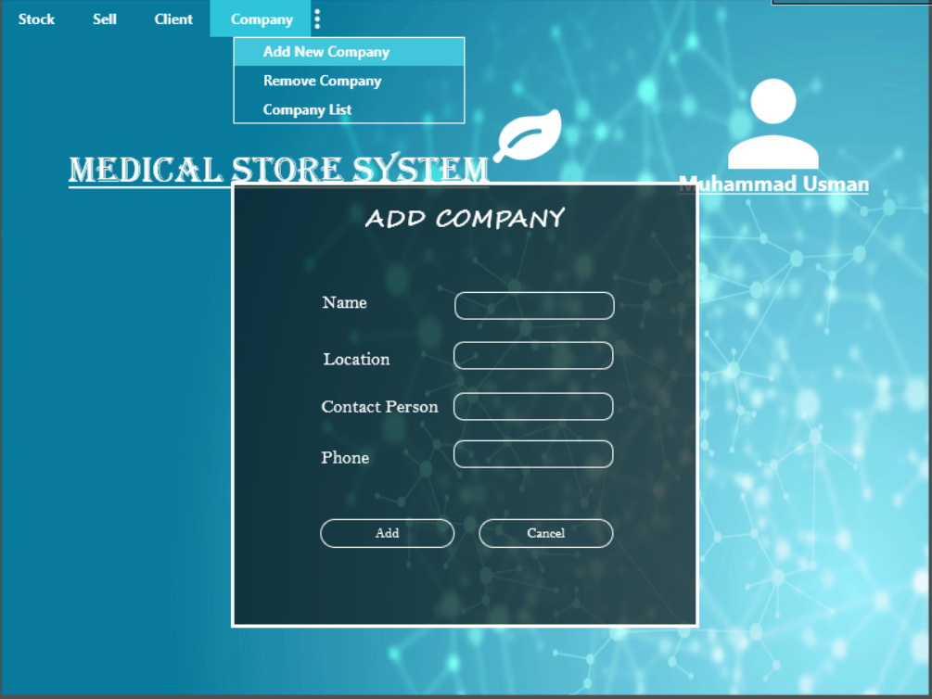

4.3.10 Add Company.

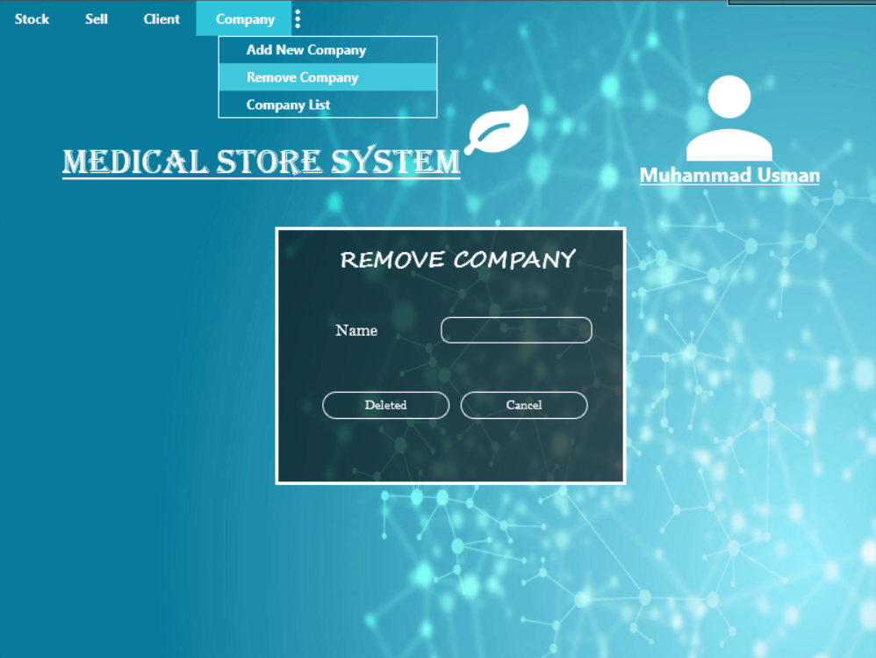

4.3.11 Remove Company.

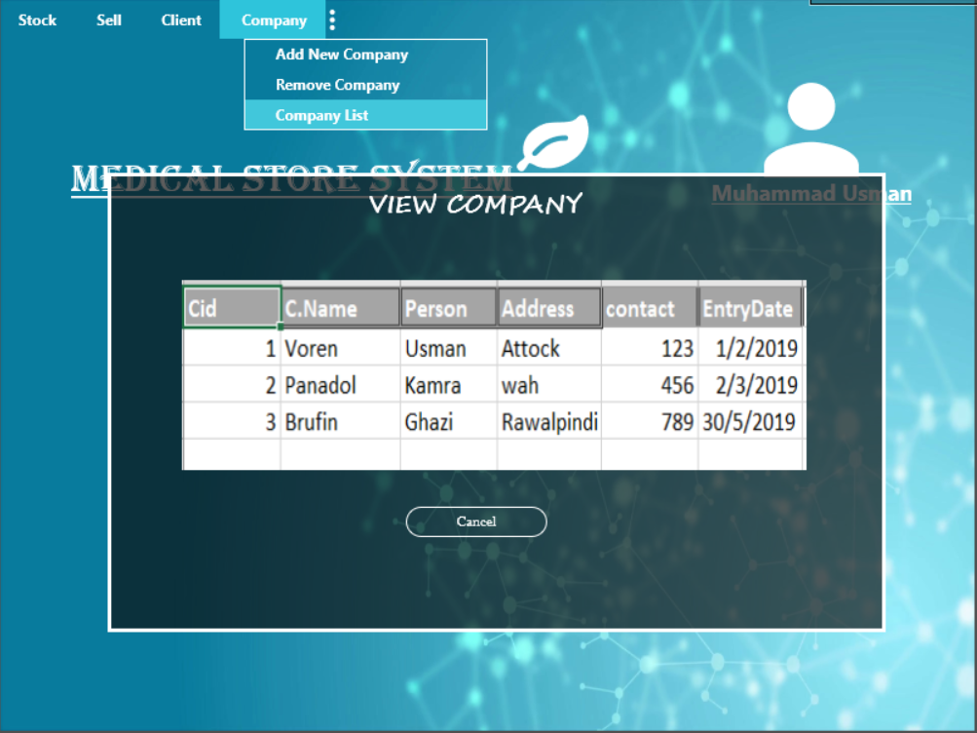

4.3.12 View Company.

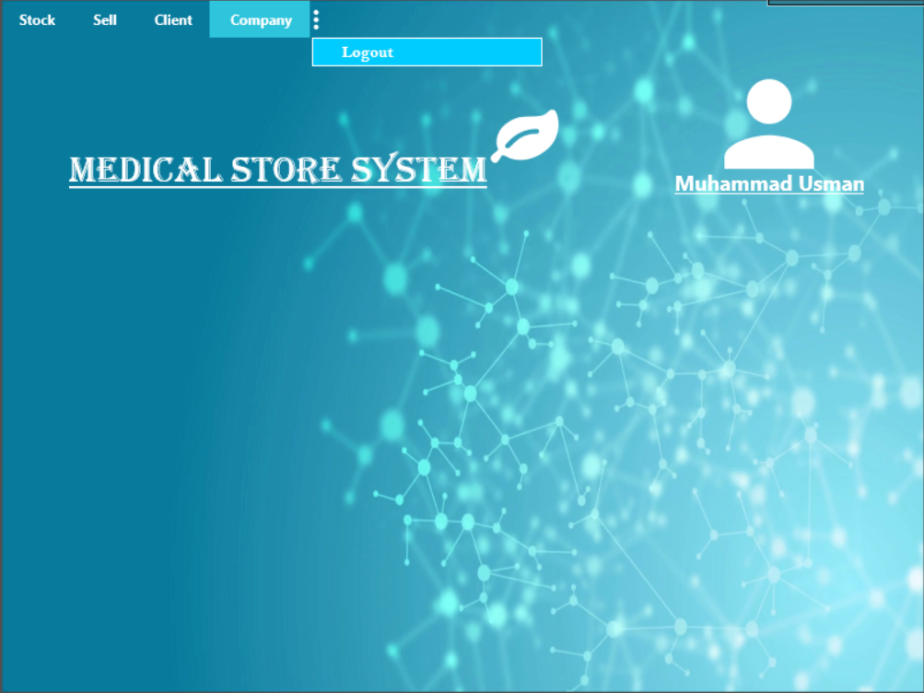

4.3.13 Logout.